**Table Numbers** Diamond (1) Platinum (2-4) Gold (5-10)

Silver (11-16)

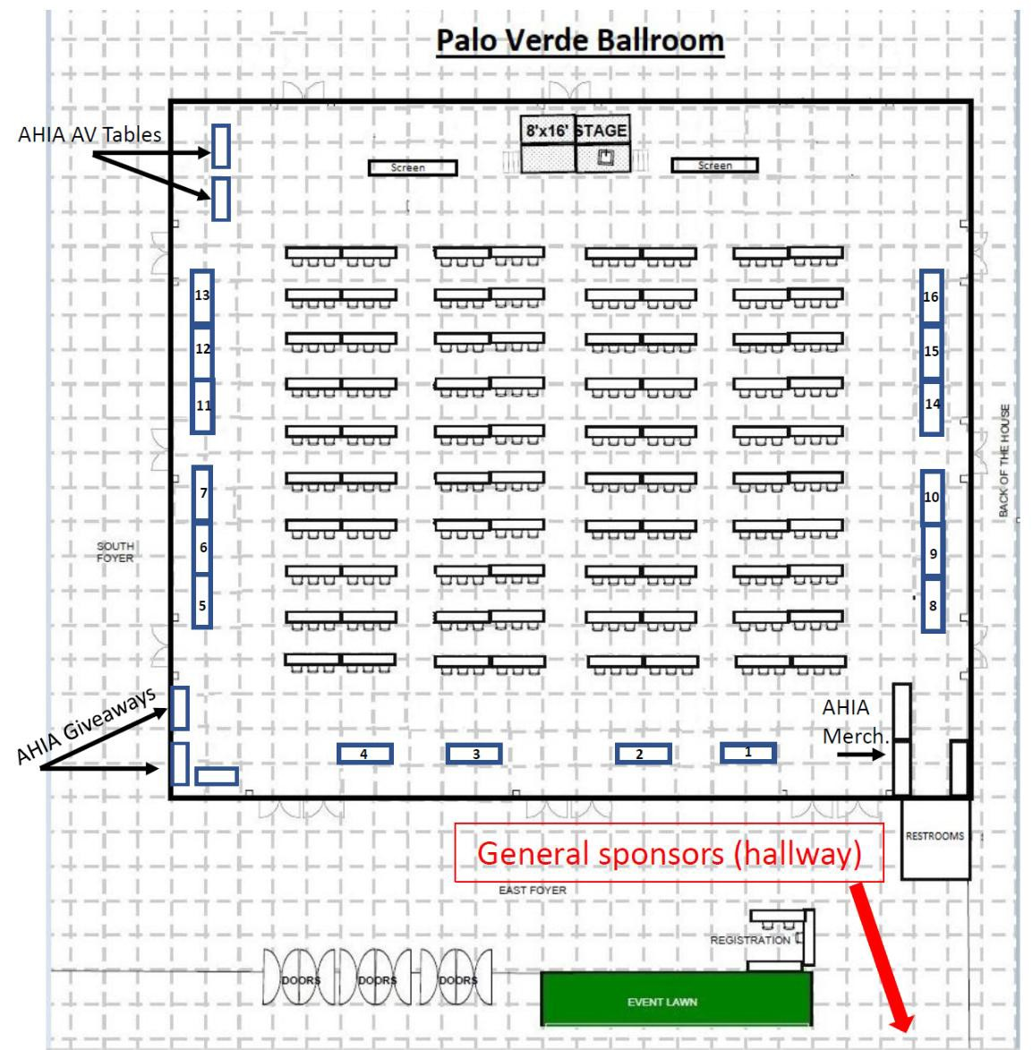**2025 Ballroom Sponsors**

1. [AllTerra Central](https://allterracentral.com/)

2. [Thermo Fisher](https://www.thermofisher.com/ch/en/home.html)

3. [DNA Labs International](https://dnalabsinternational.com/)

4.  [Joe’s AZ Bio Cleanup](https://www.az-bio.com/joes-azbio-cleaning/)

5. [Identifinders](https://identifinders.com/)

6. [Rohde & Schwarz](https://www.rohde-schwarz.com/us/home_48230.html)

7. [TACT 48](https://www.tact48.com/)

8. [Genetic Genealogy for LE](https://www.geneticgenealogyforlawenforcement.com/)

9.

10. [Cybergenetics](https://www.cybgen.com/)

11.

12.

13. [RMIN](https://www.riss.net/centers/rmin/)

14. [Proforce Law Enforcement](https://proforceonline.com/)

15.

16.

**2025 AHIA Conference Sponsors /Exhibitors Table Map**

**Table Numbers** Diamond (1) Platinum (2-4) Gold (5-10)

Silver (11-16)

**2025 General Sponsors**

17. [Pirate Cove Resort](https://www.piratecoveresort.com/)

18. [Grand Canyon University](https://www.gcu.edu/)

19. [100 Club](https://www.100club.org/)

20. [Tombstone Tactical](https://tombstonetactical.com/)

21.

22.

23.

24.

25.

26.

27.

28.

29.

30.